Keegan Smith

ADS

HW4: Seven Segment Decoding

11/21/23

1. A screen shot of a computer

   Description automatically generatedConstruct a record type named seven_segment_config with members a, b, c, d, e, f, and g all of type std_logic. This record will be the backbone of the output of your binary to seven segment display decoder. Create an unconstrained array type which uses the newly created record as the base type.
2. 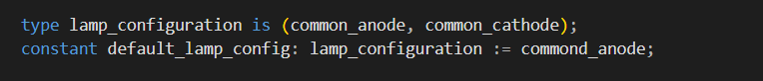Construct an enumerated type called lamp_configuration which defines the names common_anode and common_cathode. Define a constant of this enumerated type called default_lamp_config and set it to the lamp configuration of your board.
3. A screen shot of a computer screen

   Description automatically generatedUtilize the array from question 1 define a constant named seven_segment_table. Each seven_segment_config entry must describe the lamp configuration of a hexadecimal alphabet. An example alphabet is shown on Figure 1.

1. Declare a subtype of natural called hex_digit which is constrained to the range of the constant created in the previous question. Use this subtype to construct a function with the following prototype.

The function should use the seven_segment_table declared in Question 3 and return a seven_segment_config entry which activates the lamps for the given lamp_mode configuration.

1. Construct a function with the prototype which returns a seven_segment_config for the given lamp_mode so that all lamps are off.

